DEPENDENCY DESCRIPTION
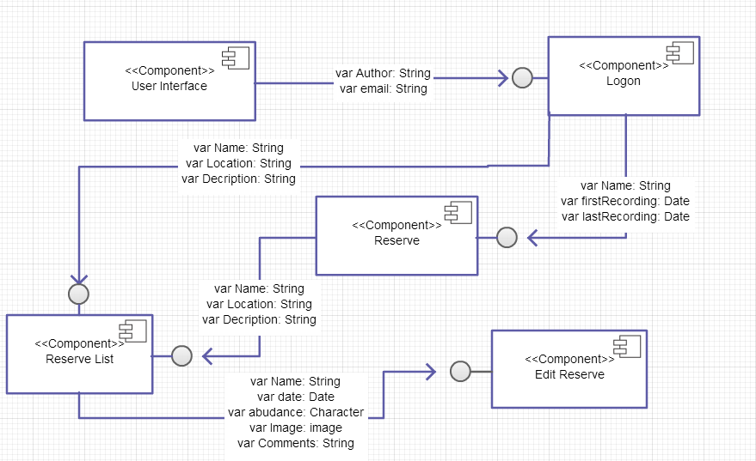
Components Diagram for Web Interface

